**COLLEGE CODE :** 3116

**COLLEGE NAME:**MNM Jain Enginerring College

**DEPARTMENT** :Computer Science & Buisness System

**STUDENT NM-ID :**B2C1835E7BF970F85EA475D760736BF2

**ROLL NO:**311623244012

**DATE :**

**TECHNOLOGY-PROJECT NAME :**AI-Driven Natural Disaster Prediction &Management System

**SUBMITTED BY,**

1. Karthikeyan B(311623244012)
2. Lourdhu priscilla(311623244013)
3. Kanagavel M(311623244011)
4. Thivahar J(311623244022)
5. Nivethitha(311623244016)

**Abstract**:

This project presents an innovative cyclone and storm alert system that predicts storm paths, provides visual notifications tailored to different literacy levels, and features a community forum for discussion and support. By leveraging advanced predictive modeling and user-centric design, the system enhances disaster preparedness and community resilience, ultimately saving lives and reducing the impact of cyclones and storms.

1**. Project Demonstration**

**Overview:**

In Phase 5, The *AI-Powered Natural Disaster Management System* will be demonstrated to highlight its real-time cyclone/storm prediction, visual alert system for all literacy levels, and community support forum. The system is designed for inclusivity, accuracy, and reliability in disaster-prone scenarios

**Demonstration**:

**System Walkthrough:**

A live walkthrough will show how the platform predicts disasters, notifies users through visual alerts and allows interaction via a community forum interface.

**Disaster Prediction Accuracy:**

Demonstration of AI models forecasting cyclone and storm paths using meteorological data.

**Visual Notifications**:

Showcase of inclusive visual alerts that are understandable across all literacy levels and languages.

**Community Forum**:

A demonstration of how users can seek help, share local updates, and interact in emergency situations via a moderated forum.

**Performance Metrics**:

The system’s ability to handle data, multiple users, and scalable alert delivery will be shown.

**Security & Privacy**:

A brief explanation of how user location and identity data are securely managed during alert handling.

**Outcome**:

The demo confirms the system's capability to provide accurate disaster warnings, inclusive alerts, and strong community support—ensuring readiness for real-world lol.

1. **Project Documentation**

**Overview**:

Comprehensive documentation is prepared to detail every component of the disaster management system, ensuring it can be maintained, scaled, and understood by future developers and users.

**Documentation Sections**:

**System Architecture**:

Diagrams showing AI prediction flow, visual alert logic, and user/forum interactions.

**Code Documentation**:

Well-commented source code for cyclone/storm path prediction, alert delivery modules, and forum functionalities.

**User Guide**:

Simple instructions for users on how to receive alerts and participate in the community forum.

**Administrator Guide**:

Maintenance procedures, system updates, and community moderation tools.

**Testing Reports**:

Performance results for alert speed, prediction accuracy, and platform scalability.

**Outcome**:

All system features are clearly documented, enabling seamless handover, future development, and practical deployment

**3. Feedback and Final Adjustments**

Overview:

Feedback will be collected from instructors and test users to refine the disaster management system before final handover.

**Steps**:

**Feedback Collection**:

Through surveys and demo observations, feedback on prediction accuracy, alert delivery, and forum usability will be gathered.

**Refinement**:

System adjustments will focus on improving forecast accuracy, alert visibility, and user interaction.

**Final Testing**:

Re-testing will validate system performance, accessibility, and community support functions.

**Outcome**:

Final adjustments will improve system reliability, inclusivity, and readiness for real-world emergency response.

**4. Final Project Report Submission**

**Overview**:

The final report summarizes the complete development of the disaster prediction and management platform, including milestones, challenges, and system performance.

**Steps**:

**Executive Summary:**

A high-level overview of the system's purpose, functionality, and achievements.

**Phase Breakdown**:

Key phases such as AI model training, data integration, visual alert design, and forum creation are outlined.

**Challenges & Solutions**:

Includes issues like forecast delays, low-literacy accessibility, and user moderation—with applied solutions.

**Testing & Results**:

Summary of system performance under load, alert timing, and user experience feedback.

**Outcome**:

The report reflects the system’s evolution from concept to deployment-ready solution, supporting further improvements and scale-up.

**5. Project Handover and Future Works**

**Overview**:

The project handover marks the transition of the disaster management system to the next phase of implementation and expansion.

**Handover**:

* Complete code, documentation, and user manuals will be handed over.

* Suggestions for future work include:

• Scaling for national/regional use

• Expanding multilingual and offline alert capabilities

• Enhancing community features and moderator tools

• Integrating satellite and sensor data for improved accuracy

**Outcome**:

The system will be officially handed over with guidance for future upgrades, ensuring it remains a vital tool for protecting communities from natural disasters.

**Screenshots for code and progress:**

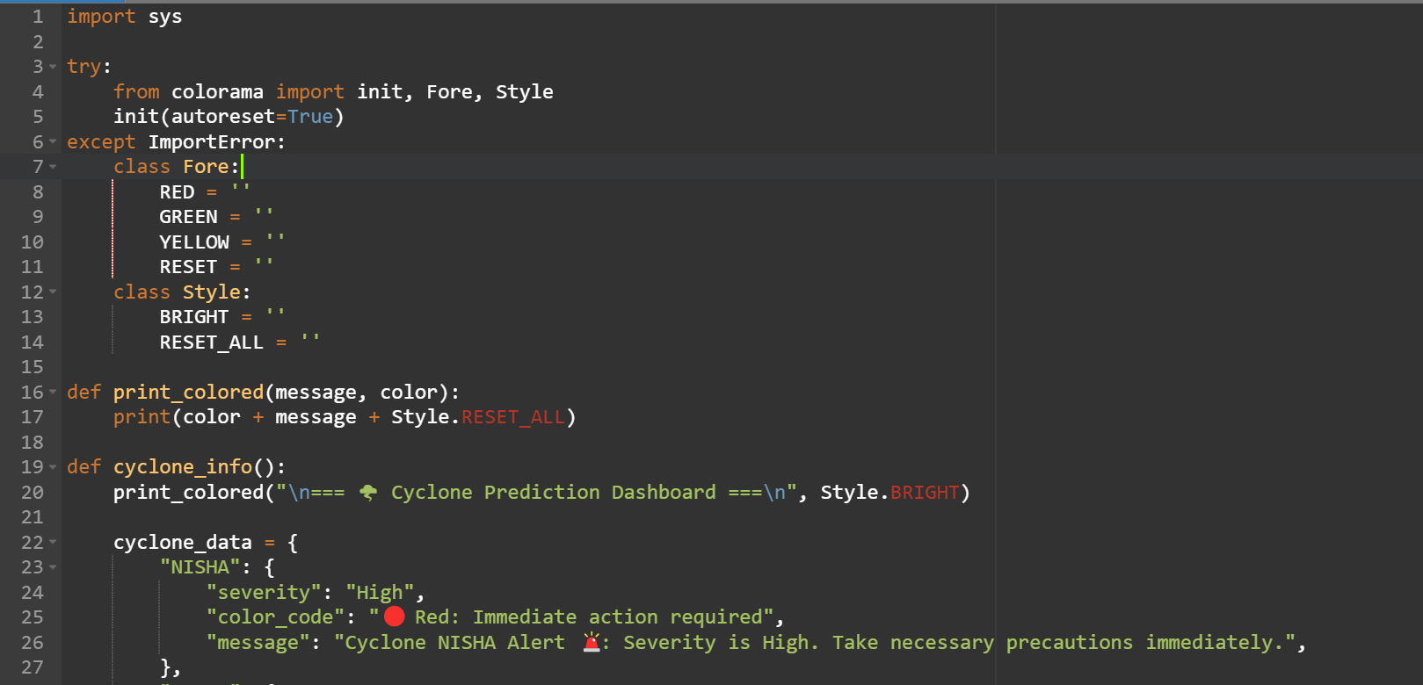

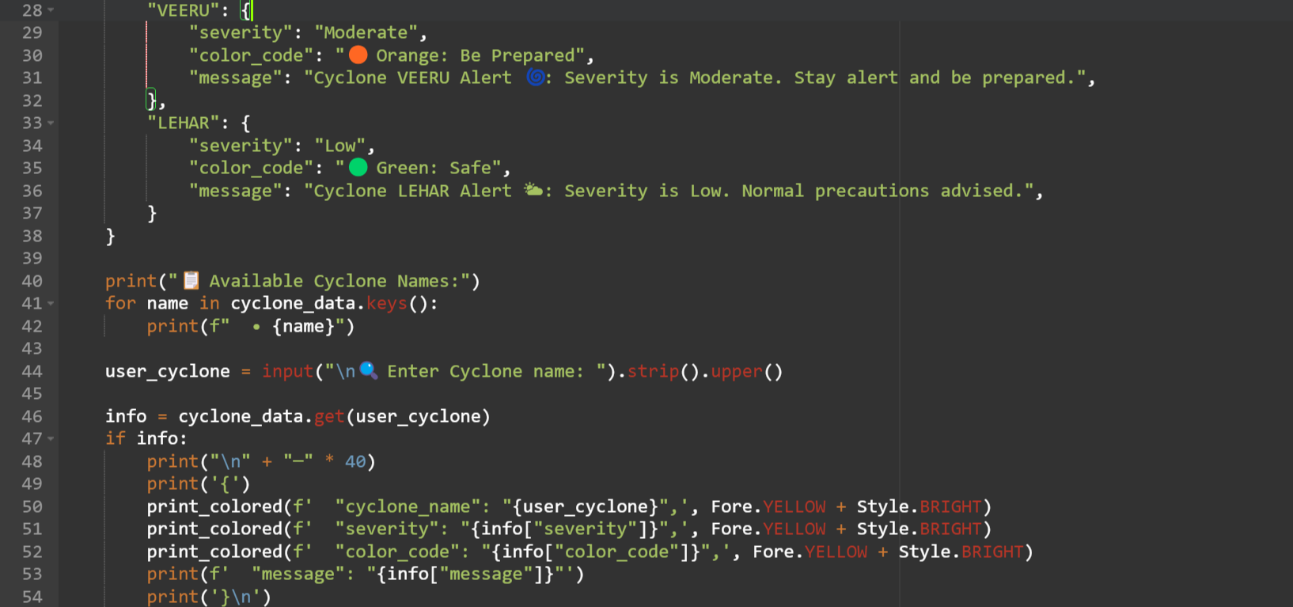

**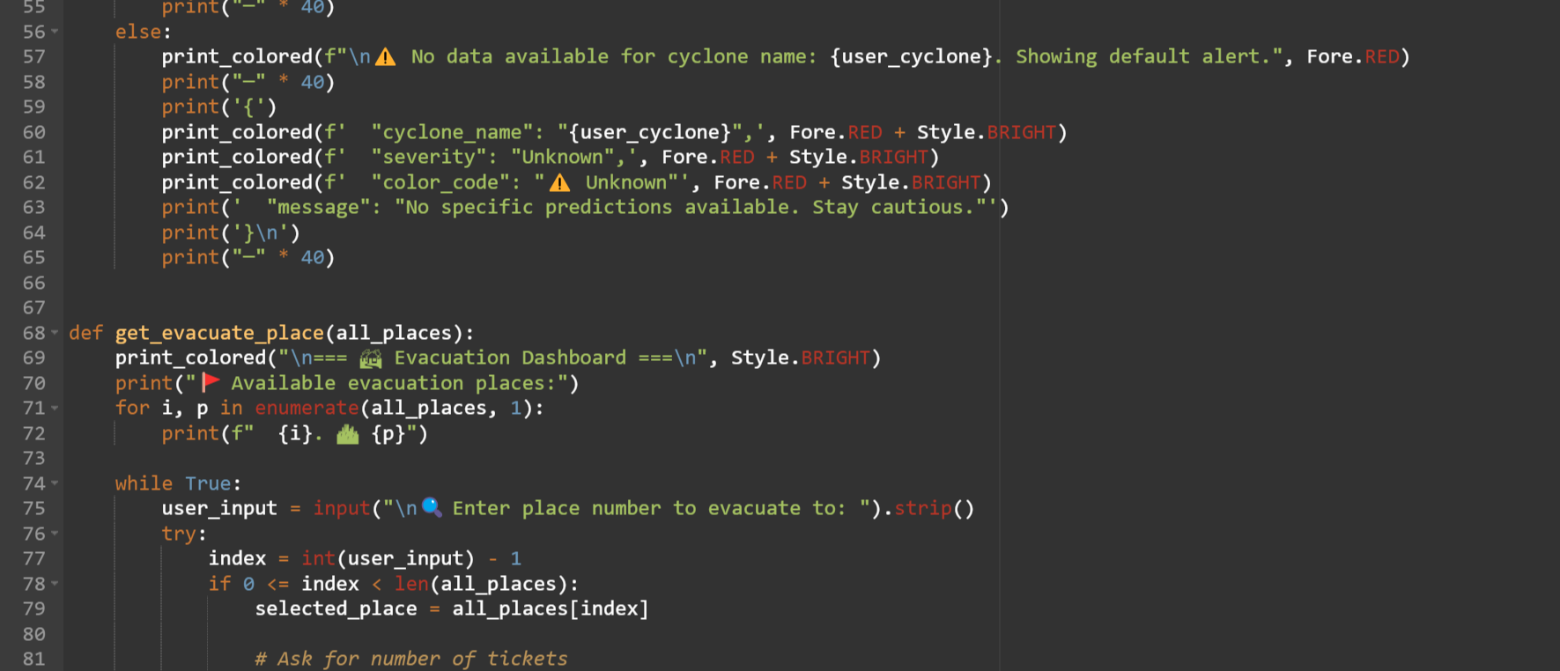  
   
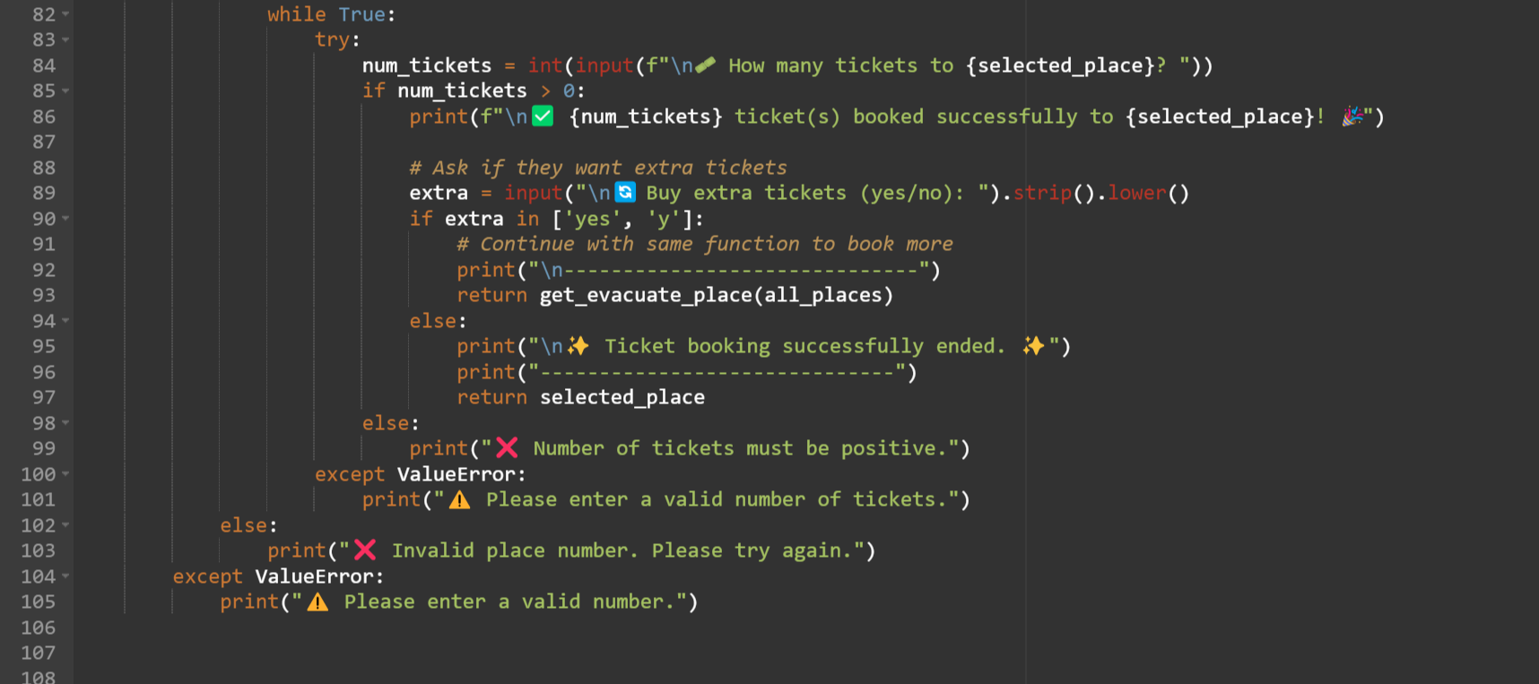  
  
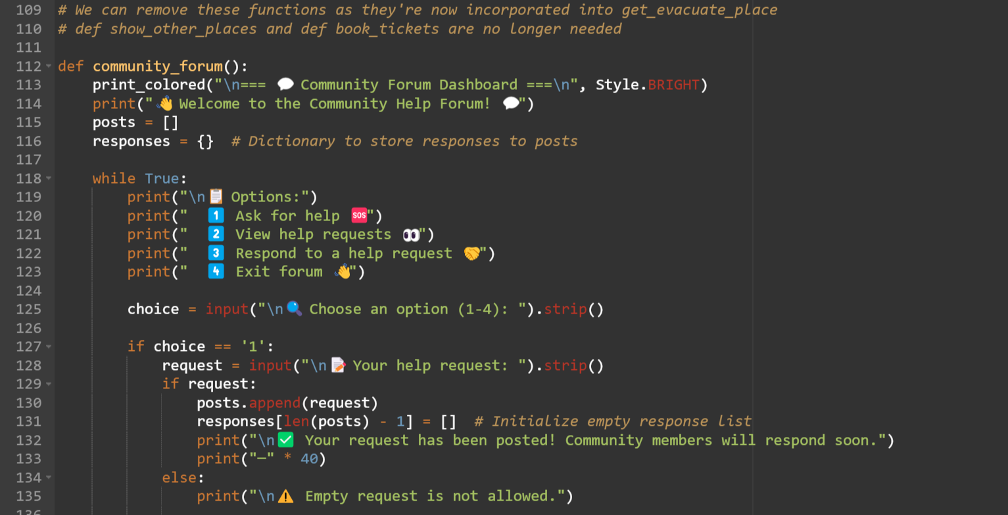**

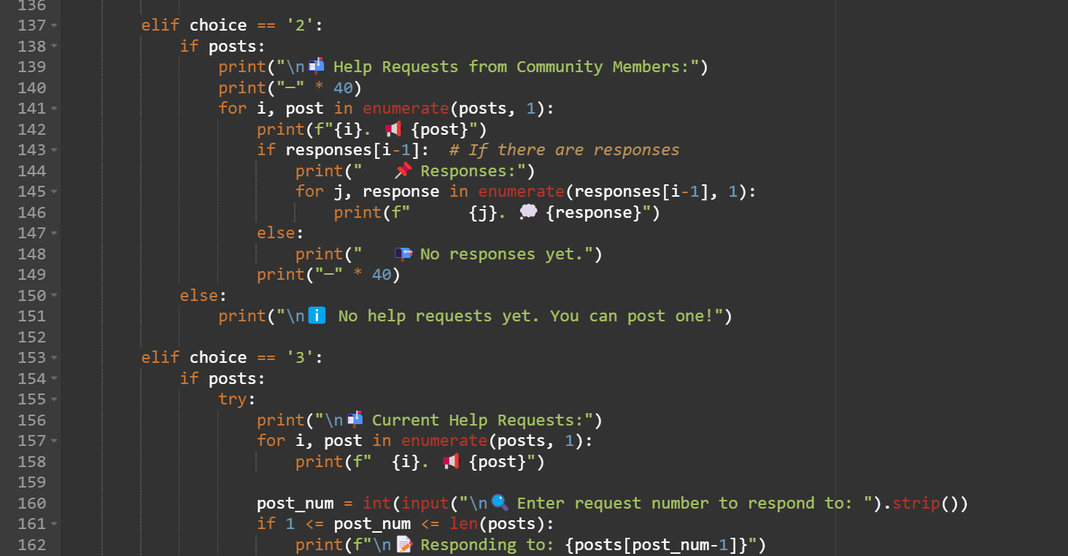

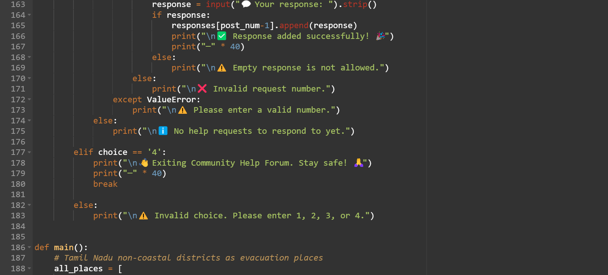

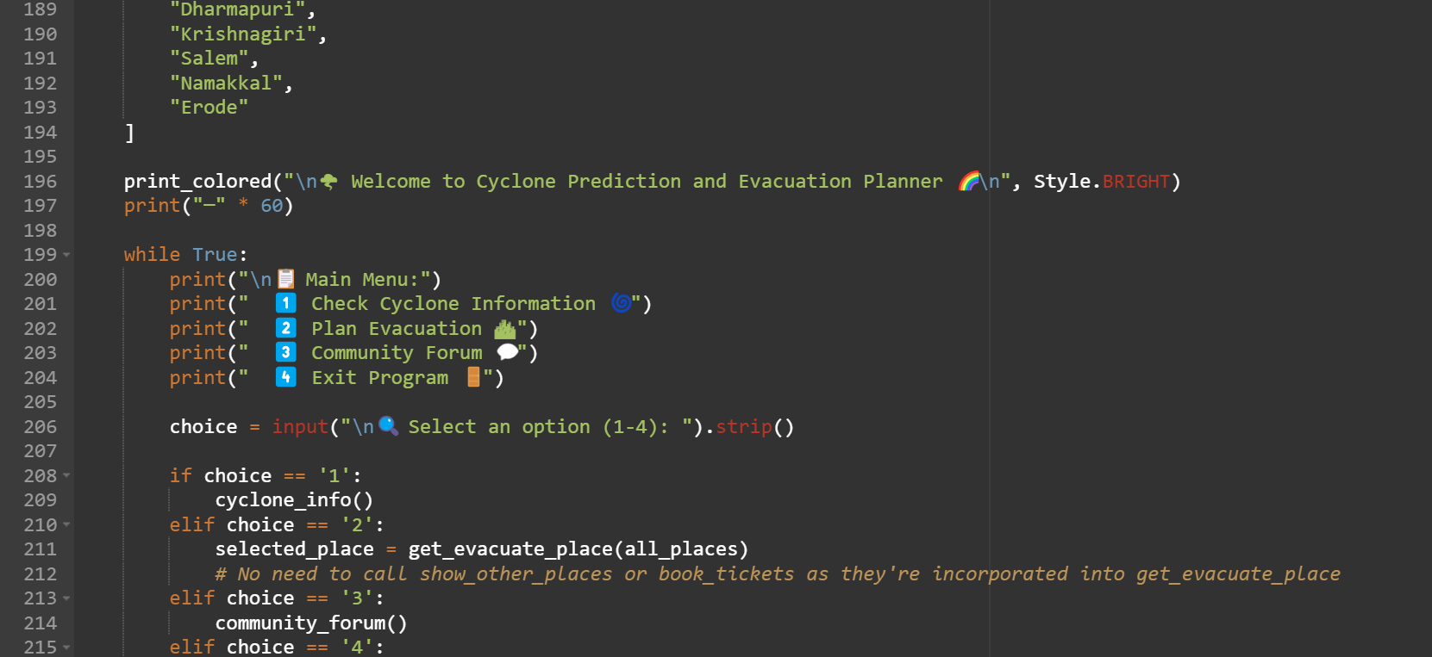

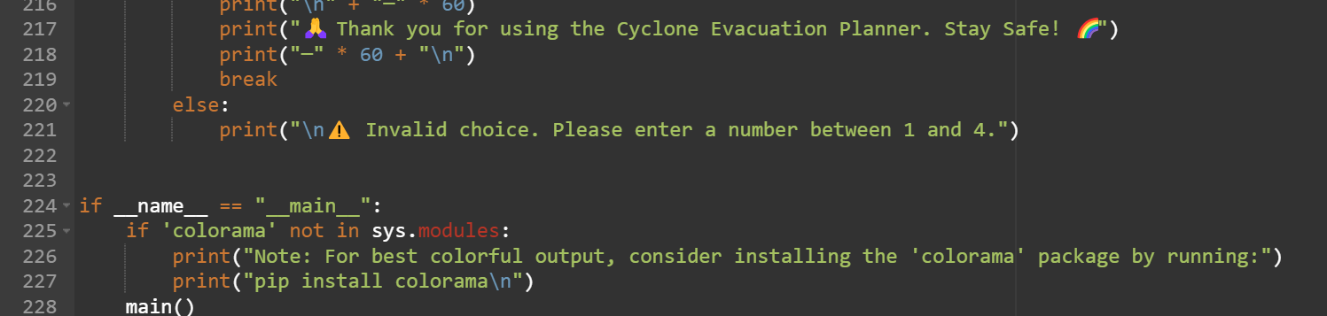

**Output:**

